## Project Management Tool – Jira with Zephyr Plugin

**Trainer Management System**

**Batch 2 – Group 7**

We have used Jira for issue tracking and project management. JIRA dashboard consists of many useful functions and features which make our project handling easy. We have created different Sprints for each week and create tasks under each sprint. And tried to complete each sprint during that time schedule.

### 

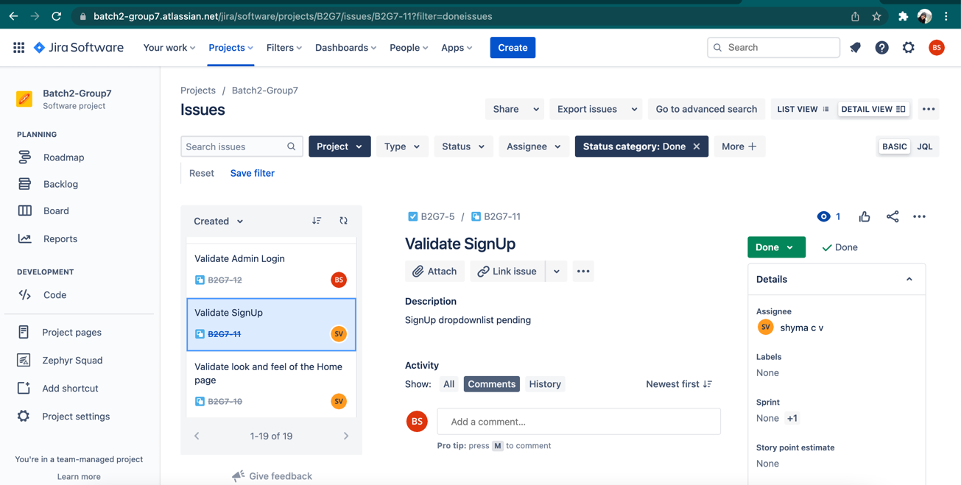We have assigned Test Scenarios to each team member and marked the progress accordingly.

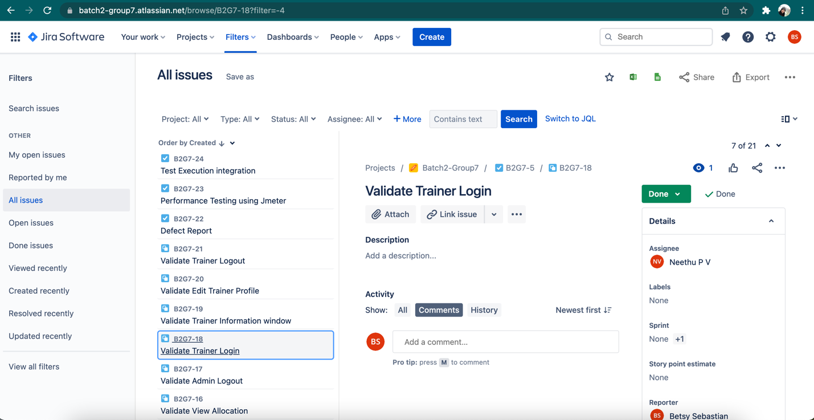

We can view activity going on the issue, reviews on the issue, work log, history of the issue and so on.

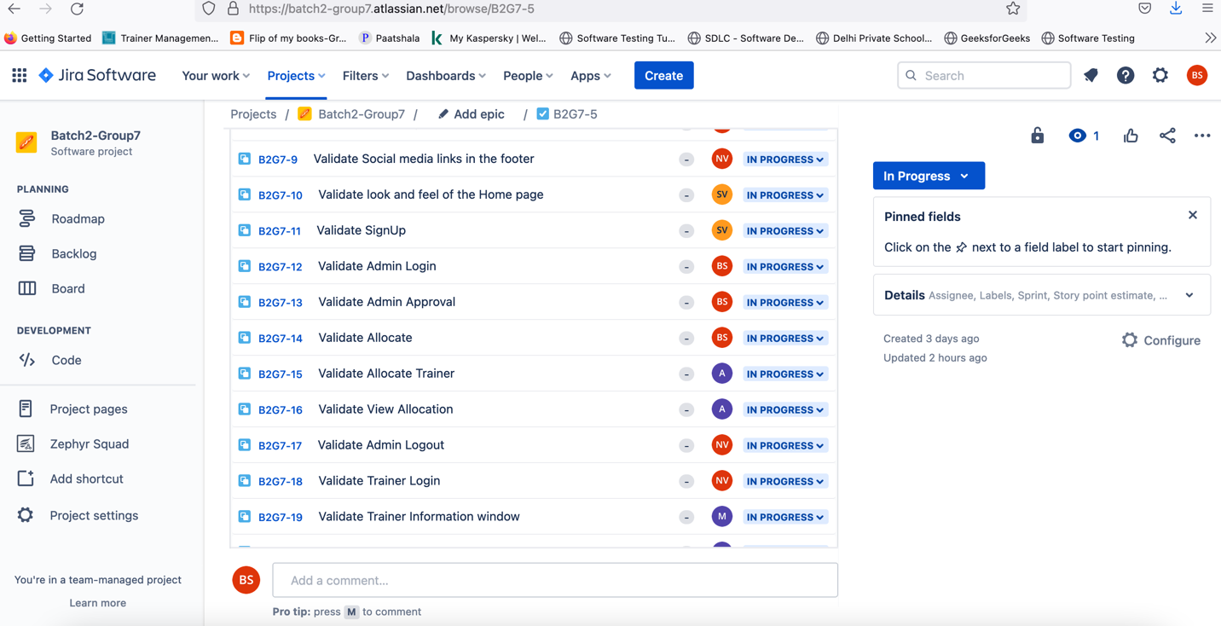

### 

### Bug Tracking

### 

### Plug-ins in JIRA

There are plug-ins available for JIRA to work more effectively, some of these plugins are Zendesk, Salesforce, GitHub, Gitbucket and so on. We have tried to use Zephyr, which enables to import Test cases directly and offered may charts and reports for better tracking.

